Scholarship Management System - Phase II: Business Process Modeling

1. Scope Definition

Business Process: Scholarship Application and Management Process
Scope Definition: This model covers the entire scholarship lifecycle from publication to disbursement, including:
- Scholarship creation and publication
- Student application submission
- Application review and evaluation
- Selection and award notification
- Fund disbursement and tracking
- Reporting and analytics
Objectives:
- Automate manual processes to reduce administrative burden
- Ensure fair and transparent selection based on predefined criteria
- Create a centralized information system for all scholarship-related activities
- Enable real-time tracking of applications and disbursements
- Support data-driven decision making through comprehensive reporting
Expected Outcomes:
- Reduced processing time for scholarship applications
- Improved accuracy in eligibility verification
- Enhanced transparency in selection process
- Streamlined fund disbursement
- Comprehensive audit trail of all activities-
- Increased student satisfaction through improved communication

2. Identify Key Entities

Scholarship Providers
- Role: Create scholarships, define eligibility criteria, allocate funds
- Responsibilities: Set scholarship parameters, approve final selections, provide funding
- Interactions: Communicate with administrators, review summary reports

Administrators
- Role: Manage the scholarship system, oversee application review process
- Responsibilities: Configure system settings, assign reviewers, monitor process metrics
- Interactions: Coordinate with providers and reviewers, generate reports, approve disbursements

Reviewers
- Role: Evaluate scholarship applications based on criteria
- Responsibilities: Assess applications, score candidates, provide feedback
- Interactions: Coordinate with administrators, access application details

Students
- Role: Apply for scholarships, provide documentation
- Responsibilities: Submit accurate information, respond to queries, accept awards
- Interactions: Submit applications, track status, receive notifications

Financial Department
- Role: Process scholarship disbursements
- Responsibilities: Verify account details, disburse funds, maintain financial records
- Interactions: Coordinate with administrators, process payments to students

Scholarship Management System (SMS)
- Role: Central information system that facilitates the entire process
- Responsibilities: Store data, automate workflows, enforce rules, provide interfaces
- Interactions: Connects all stakeholders, manages data flow, generates notifications
3. Business Process Model with Swimlanes
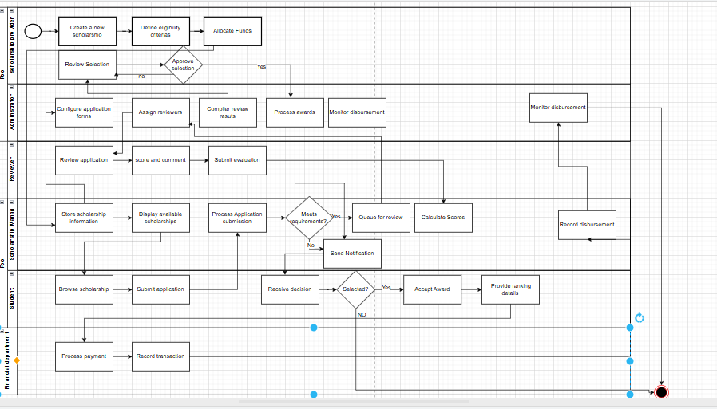

4. Application of UML/BPMN Notations
In the BPMN diagram above, I've used the following notation elements:
- Swimlanes: Six horizontal swimlanes represent each key entity (Scholarship Provider, Administrator, System, Student, Reviewer, Financial Department)
- Activities/Tasks: Rectangular boxes represent specific tasks performed by each entity
- Sequence Flows: Arrows connect activities showing the order of execution
- Start/End Events: Implied by the first and last activities in each swimlane
- Data Objects: Implied through the information passed between activities

5. Logical Flow Explanation
The process follows a logical sequence:
- Scholarship Creation & Publication Phase:
  - Scholarship providers create scholarships with defined criteria and funding
  - Administrators configure the system to capture required information
  - The system stores and displays available scholarships to students
- Application Submission Phase:
  - Students browse scholarships and submit applications with supporting documents
  - The system verifies application completeness and basic eligibility
  - Complete applications are queued for review, while incomplete ones are rejected
- Review & Selection Phase:
  - Administrators assign reviewers to applications
  - Reviewers evaluate applications against criteria and provide scores
  - The system calculates final scores and ranks applications
  - Administrators generate selection lists for provider approval
- Award & Disbursement Phase:
  - Approved selections trigger notifications to students
  - Selected students accept awards and provide banking information
  - Financial department verifies and processes payments
  - The system maintains an audit trail of all transactions
- Reporting & Closure Phase:
  - System updates statuses and maintains records
  - Administrators generate comprehensive reports
  - All activities are properly documented for future reference

6. Process Model Explanation

Main Components and Their Interactions
The Scholarship Management System integrates six key entities that interact through a centralized information system:
Scholarship Providers initiate the process by creating scholarships and defining parameters. They also have final approval authority for selections. Their interactions are primarily with administrators and the system.
Administrators serve as process orchestrators, configuring the system, assigning reviewers, monitoring progress, and facilitating communication between other entities. They interact with all other stakeholders.
The System acts as the central hub, storing data, enforcing rules, automating workflows, and facilitating communication. It connects all stakeholders and manages information flow.
Students are the primary users who browse scholarships, submit applications, and receive funds. They interact mainly with the system but receive outputs from other entities through notifications.
Reviewers evaluate applications based on predefined criteria. They interact with the system to access applications and submit evaluations, which feed into the selection process.
Financial Department manages the fund disbursement process, ensuring payments reach selected students. They interact with the system and administrators to process and track payments.

MIS Support Functions
This process supports key MIS functions in several ways:
- Decision Support: The system provides structured evaluation criteria and scoring mechanisms that help reviewers make objective assessments. It also generates ranked lists that facilitate administrator and provider decisions about awards.
- Data Integration: The system centralizes all scholarship-related data from multiple sources (providers, students, reviewers) into a unified platform, eliminating silos and ensuring consistency.
- Process Automation: Manual tasks like eligibility checking, notification sending, and status updating are automated, reducing administrative burden and human error.
- Real-time Monitoring: Administrators can track the status of applications, reviews, and disbursements in real-time, allowing for timely interventions when needed.
- Analytics and Reporting: The system captures comprehensive data that enables analysis of scholarship allocation patterns, success rates, and process efficiency metrics.

Organizational Importance
This business process is critical for organizational efficiency for several reasons:
- Resource Optimization: By automating routine tasks, staff can focus on higher-value activities like developing scholarship programs and improving selection criteria.
- Transparency and Compliance: The system ensures that scholarship awards follow predefined criteria, maintaining fairness and compliance with organizational policies and regulations.
- Stakeholder Satisfaction: Students receive timely updates and fair consideration, providers gain visibility into how their funds are allocated, and administrators benefit from streamlined workflows.
- Data-Driven Improvements: Comprehensive tracking enables analysis of program effectiveness, allowing organizations to refine scholarship programs based on outcomes.
- Risk Mitigation: The structured process with built-in verifications reduces the risk of errors, fraud, and misallocated funds.

